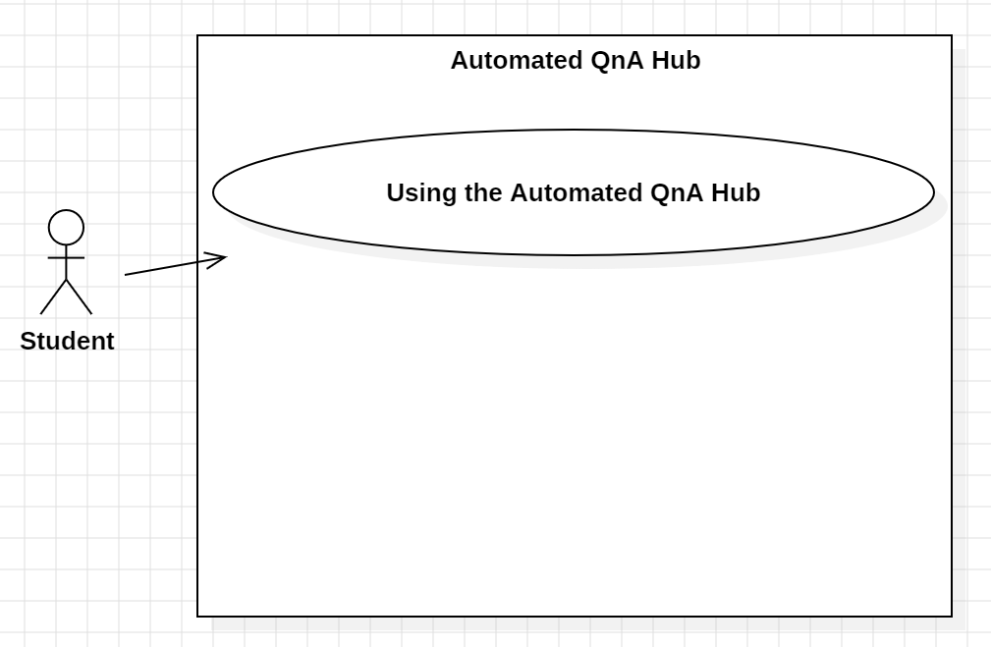
USE CASE |  | 1 | Using the Automated QnA Hub
Description of Goal in Context |  | A student will use the system when they want to ask a question about an assignment and then receive an answer from it.
Preconditions |  | -The student is logged into their account.  -A teacher has set up the section for the assignment where questions can be asked within the section for their module.
Post Conditions, Success End Condition |  | The state will remain the same as it was before operation.
DESCRIPTION of Scenario |  | < The long description of the scenario to be analysed.  The use case description is a more complete description identifying behaviour, it comes from the requirements gathering>
Main Flow
Step | Action |  |  | Alternate
1.1 | Student logs into their account created for the website.
1.2 | Student navigates to the relevant module section.
1.3 | Student selects the relevant assignment section.
1.4 | Student enters their question about the assignment in the chatbox.
1.5 | Student receives a satisfactory answer from the system. |  |  | 1.1.1
EXCEPTIONS or ERROR Flow
Description

Step | Branching Action  < Exception number m of Use Case n> |  |  | Alternate
n.m.1 | < condition causing exception>  <Action, steps of scenario to goal delivery>
ALTERNATIVE or VARIATION Flow
Description
Answers from the system do not resolve the student’s query.
Step | Branching Action |  |  | Alternate
1.1.1 | Student directly contacts the teacher through other means.

